Visual inspection

STN39230-00199

Manufacturers part Number: ……………………………………….
20220900200199

Atlas serial number: ……………………………………….

Front

Rear

Manufacturer has probed pads on rows A and D
1

Scratch pads

1

“Minor” is used to describe a fault which is in no way a failure.
“Contamination” is matter which has wet the detector surface.
A “Scratch” is a result of mechanical damage to the detector surface.
An “edge chip” or “crack”is an fault to the cut edge of the wafer . The measurement given is the distace that the chip or crack extends
perpedicular to the wafer edge.

Edge chipping <60um
Minor light scratching worse in corners.
Scratch pads
Minor contamination x 2
2 Sets of deeper parallel scratches

20220900200199

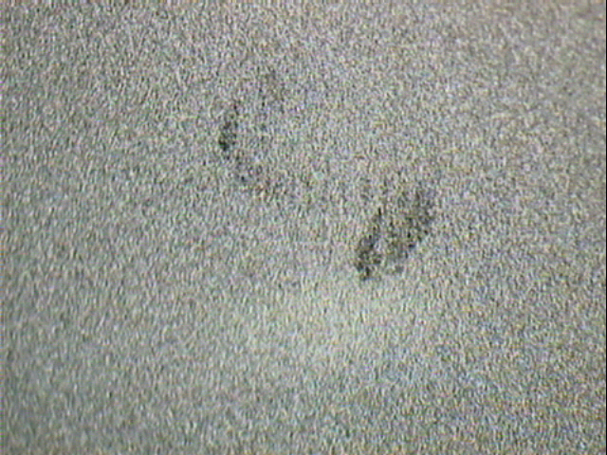

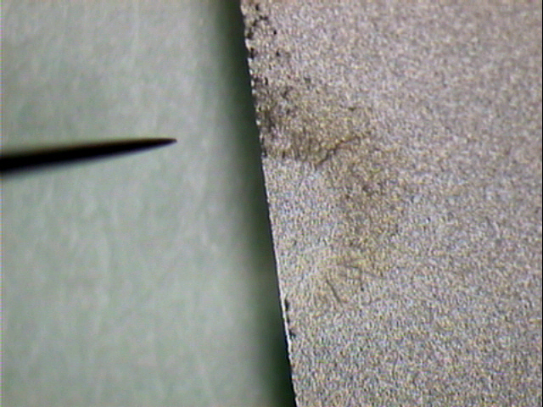
20220900200197

