Visual inspection

STN 39194-00023

Manufacturers part Number: ……………………………………….
20220900400023

Atlas serial number: ……………………………………….

Front

Rear
Splatter type contamination
Large scrape / contamination
Small edge chip
Manufacturer has probed pads on rows A and D
20220900400023

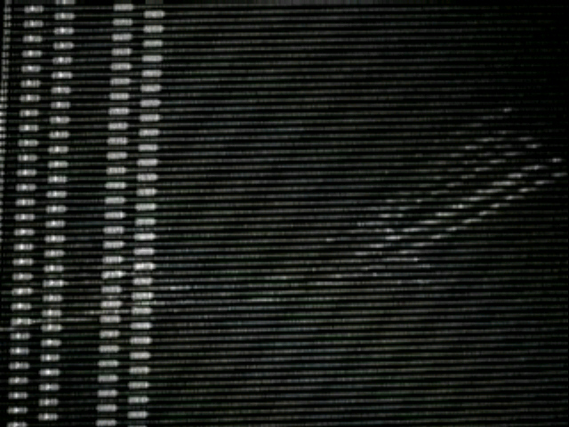

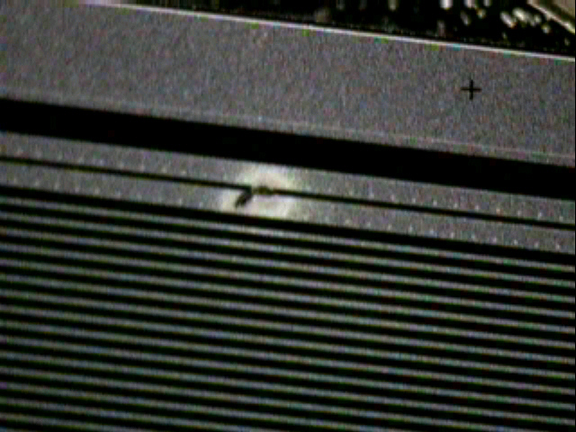

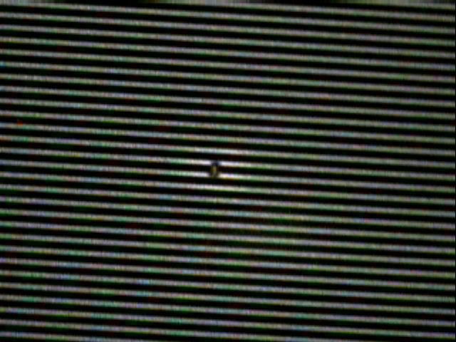
“Splatter” on strips 505,506
which appear as a short on the strip scan. This suggests the problem is conductive.

