PHY340 Data Analysis Feedback:

Group P03 doing Problem P5

# Data Analysis

The data analysis seems generally correct, but too few values are reported: you state that you restricted your fit to regions in which there were clear oscillations, but you never explicitly say what these ranges were or how you selected them (I assume that the ranges shown in the plots are the fit ranges, but they might not be—it is not uncommon to show a fitted function extended over a greater range than was actually used for the fit). In fact, you do not show the fitted parameter values at all, which makes it difficult to assess your final results: Mark Fox is con­cerned that the 4 T point on your figure 6 does not have a noticeably larger error bar than the points for lower fields, which appear to give better fits. I know, because I’ve fitted the data my­self, that in fact the fitted *ω* value is surprisingly robust, and has a small error even for the 4 T data (in contrast to the errors on *A* and *τ*, which are huge), but you have not discussed this or presented the numbers to justify it.

In the absence of error bars, the coefficient of determination is not a bad measure to present for goodness of fit, but it is not ideal: a small coefficient of determination may mean a poor fit, or it may imply large error bars. You could also quote the RMS residual, i.e. $\sqrt{\left\langle {\left(y_{i}-y_{\text{fit}}\right)}^{2}\right\rangle }$, which is a direct measurement of the difference between the measured and fitted *y* values. I found that the coefficient of determination was indeed lower for the 4 T data (mine was lower than yours, probably because I used a different fit range), but the RMS residual was much the same for each fit: if anything, it was smaller for the 4 T data. That suggests that the fit is not really worse for this sample: the signal-to-noise ratio is poorer because the signal is smaller. Again, this would be easier to discuss if you had quoted your fit results. The fact that you and I get slightly different answers (you get 0.5776±0.0059, I get 0.5756± 0.0039) suggests that the choice of fit range introduces a systematic error, which would not be at all surprising; it would have been nice if you had explored this by varying your fit range.

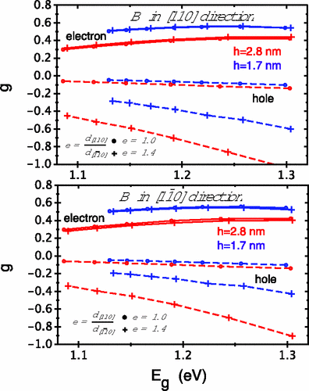

*Figure 1: electron and hole g-fac­tors in InAs/GaAs quantum dots, from Pryor and Flatté, Phys. Rev. Lett.* ***99*** *(2007) 179901.*

Although you say that “the hole precession with [sic: I think you mean “will”] result in a positive g-factor, associated with the positive hole charge”, your equation (2) taken at face value would give a negative *g*. You do not explain why you prefer a positive sign (I found several negative values in the liter­ature, see for example figure 1).

Average mark for this section: 34/50

# Data Presentation

The data are clearly presented, but figures 2−5 belong in the main text: they are a key part of your analysis, and should not be relegated to an appendix. You seem to be aware of this, because your figure numbers are out of sequence: if the figures were presented in numerical order, they’d be in the *right* order!

Generally, numerical values are presented appropriately, except that there aren’t enough of them: you need a table giving the fit results, as mentioned above. There is one case where a number is quoted to an inappropriate level of precision: −1.228±1.409 should certainly be rounded to −1.2±1.4 (especially as it is never used for anything). There should be spaces between numbers and units (“1 T”, not “1T”) and between parts of a compound unit (“Hz T−1”, not “HzT−1”). Units should *never* be italicised (in principle, not even when the rest of the text is in italics).

One would normally plot data as points, rather than a line, and I’m not convinced that blue and green provide optimal contrast. It would have been useful to plot at least one dataset in full (not just for the selected fit range) in order to illustrate why it is necessary to cut out the first 150 ps or so. It would also be good practice to indicate the magnetic field value as part of the legend of the plot, not just in the caption.

Average mark for this section: 21/30

# Style

The report is too short: more discussion of the results is necessary, as discussed above. However, it is well written on the whole—barring a few minor grammatical errors—and in the correct style. As noted above, the arrangement of material could be improved: the plots showing your fits to the data really need to be in the main body of the text. However, in general, this was a well presented report.

Average mark for this section: 14.5/20

Overall average mark: 69.5%