MICE Target Hardware*
C. Booth, P. Hodgson, P. J. Smith, The University of Sheffield.
J. Tarrant, Rutherford Appleton Laboratory.
Abstract
The MICE Experiment [1] requires a beam of low energy muons to demonstrate muon cooling. This beam is derived parasitically from the ISIS accelerator. A novel target mechanism has been developed that inserts a small titanium target into the proton beam on demand. The target remains outside the beam during acceleration and then overtakes the shrinking beam envelope to enter the proton beam during the last 2 ms before beam extraction.
The technical specifications for the target mechanism are demanding, requiring a high acceleration with precise and reproducible location of the target each cycle. The mechanism operates in a high radiation environment, and the moving parts are compatible with the stringent requirements of the accelerator’s vacuum system. This paper describes the design of the MICE target and how it is able to achieve the required acceleration whilst still meeting all of the necessary requirements for operation within the ISIS vacuum.

The MICE Experiment
The goal of the MICE experiment is to construct a section of cooling channel long enough to demonstrate a measurable cooling effect. This is achieved by reducing the transverse emittance of a muon beam by the order of 10%. Several different particle detectors will be used to measure the cooling effect with high precision, the aim being to achieve an absolute accuracy on the measurement of emittance of 0.1% or better. The emittance measurements will be performed with muon beams of different momenta within the range of 140 to 240 MeV/c and a variety of beam optics and absorber materials will be tried.

Muon Source
The ISIS accelerator based at the Rutherford Appleton Laboratory in the UK is a high power neutron spallation source. It accelerates protons from a kinetic energy of 70 MeV at injection to 800 MeV at extraction, over a period of 10 ms. The next injection follows 10 ms later. The MICE target has been designed to operate parasitically on the accelerator, inserting a small titanium shaft into the proton beam during the last 2 ms prior to beam extraction. Pions created by the interaction are collected, their subsequent decay providing the source of muons for the MICE experiment. The MICE target must be completely outside the beam during injection and acceleration, being driven to overtake and enter the beam in the 1-2 milliseconds

*We wish to thank the MICE collaboration and the ISIS Division at the STFC Rutherford Appleton Laboratory for the invaluable help and support in the performance of this work.

before extraction where the protons are close to their maximum energy. The target must then be outside the beam envelope again before the next injection.
To achieve this, the acceleration required of the target is of the order of 900 ms^{–2}, or ~90 g.
During the 10 millisecond acceleration period the beam at the target location shrinks from a radius of ~48 mm to ~37 mm. Since the exact position of the edge of the beam and the intensity of the halo shows to some variation, the insertion depth of the target needs to be adjustable. MICE will only sample the beam at a rate of a few Hz, so actuation is on demand, synchronised to trigger signals from both MICE and ISIS.

the target drive
The target drive is a brushless DC permanent magnet linear motor. This motor consists of a moving magnetic assembly on a long circular cross-section shaft. This shaft is propelled by the interaction of the magnets with a series of coils contained within the stator body.

The Stator
The stator, illustrated in Figure 1, consists of a cylinder containing 24 flat coils mounted around a steel tube. Individual coils, with an inner diameter of 18.3 mm, consist of 36 turns of copper wire and have an axial thickness of 2.85 mm. After winding, each coil is impregnated with insulating varnish to form a stable compact unit. During assembly six thin copper shims are placed between each pair of coils to facilitate heat conduction out of the coil stack. The addition of the copper shims gives a coil pitch of 3mm. Connecting leads from the coils are led radially outwards. Three thermocouples are inserted between three pairs of coils to enable the temperature of the coil stack to be monitored. A coiled copper tube soldered onto a solid copper jacket is placed around the coils in contact with the copper shims. This carries the cooling water, and the temperature of the water is monitored at either end with thermocouples. The entire assembly is inserted into an aluminium outer cylinder, the stator body, with the insulated copper wires and the cooling pipes emerging through a slit in the side. The individual coils are wired up at terminal blocks placed external to the stator body.

The Shuttle
The shuttle consists of a magnet assembly mounted on a long cylindrical shaft. An optical readout vane is attached to the top of the shaft and the whole assembly is coated with Diamond Like Carbon (DLC) [2] to minimise friction.
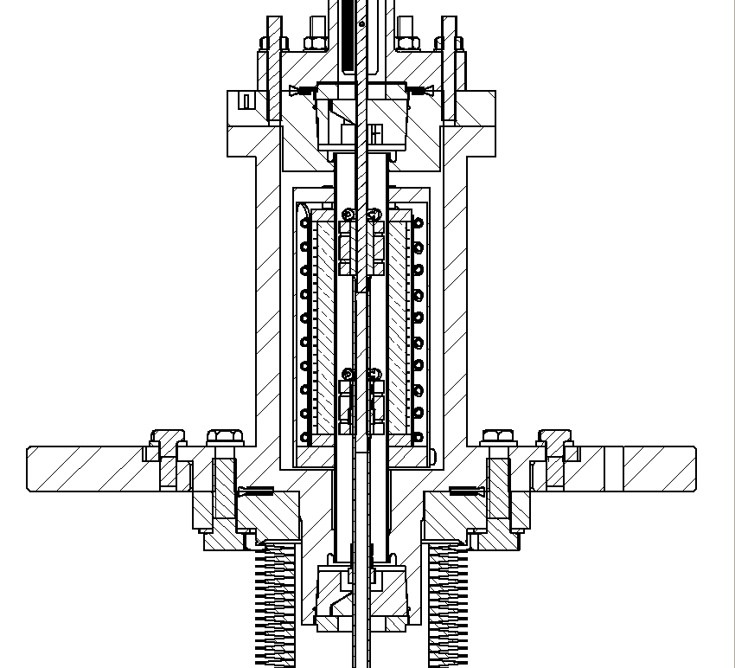
Magnets
Target Shaft
Stator Body
Bellows
Lower Bearing
Upper Bearing
Figure 1: The target body showing the stator mounted within the flanges and supporting the top and bottom bearings.
The titanium shaft is constructed from two circular cross-section pieces, an upper solid section and a lower hollow tube. Two flat faces are machined into the upper section to act as the anti-rotation mechanism and a mechanical stop is fitted at the intersection between the two pieces. This design replaces the cruciform style used in earlier shafts and allows much higher tolerances to be obtained ensuring the shaft runs straight and true. The shaft is coated with DLC to minimise friction and to give a hard wearing surface.
The magnet assembly consists of three radial magnets. Each of the magnets is produced in octants. The magnet material – sintered iron-neodymium-boron – is cut into the required shapes by wire-erosion. The pieces are then appropriately magnetised, before being assembled on a mild-steel former, separated longitudinally by ceramic washers and held in place in a jig for gluing with a two-component aircraft adhesive. Once the glue is cured, the magnet unit is lightly machined to the precise outer radius required. The unit is then attached to the shaft, as described above.
The currently installed shaft passes through two DLC coated steel bearings, one above and one below the stator assembly. These bearings maintain the magnet unit on the axis of the stator while allowing longitudinal (vertical) movement with minimal friction. Note that this bearing design has been the focus of considerable effort and an upgrade program is in progress.
Position sensing is performed using a quadrature system viewing an optical vane mounted in the slot at the top of the shaft. The vane is a wire-eroded double-sided “comb” of 0.2 mm thick steel, having 157 teeth 0.3 mm wide (with 0.3 mm gaps) and 3 mm long on one side of a 6 mm wide spine, and a single similar tooth two-thirds of the way down the vane on the other side.

Support & isolation mechanism
The target must be actively levitated to keep it out of the beam. Any mechanical or electrical failure would result in an obstruction to ISIS. To mitigate this possibility an isolation and jacking system was designed and incorporated to allow the drive to be removed. The drive is supported from a steel plate below a heavy frame, accurately located in the ISIS vault. Between the two is a screw jack, driven by a stepper motor. A set of thin-walled UHV bellows connects the two assemblies allowing the lowest position of the target to be lifted above a gate valve. Closure of the gate valve separates the vacuum space surrounding the target from the ISIS beam.

Position sensing and control
Knowledge of the position of the target is required for both control and monitoring purposes. The stator coils are driven from a 3-phase pulse width modulated (PWM) power supply, and to achieve maximum shuttle acceleration the phase of the current through the coils must be rapidly switched to track the precise position of the magnets. In addition it is necessary to monitor the depth of insertion of the target into the beam and correlate this with particle production; future cycles of target insertion can then be adapted accordingly.

Optical Readout
The position of the shuttle is measured with an optical quadrature system. As described above, the top of the shaft carries a readout vane in the form of a comb with a pitch of 0.6 mm. The teeth on the comb interrupt three laser beams; the quadrature modulation of two of these beams is used to determine the change in the shuttle’s position whereas the third beam fixes the absolute position. As the target assembly is in a high radiation environment, all active optical and electronic components are situated remotely, and signals are delivered to and from the readout via optical fibres.

Control and Power Electronics
There are a number of modes of operation of the target drive. These include the reversible movement from a powered off state, also known as “park”, to a raised “hold” position (outside the beam), “enabled”, when the electronics is waiting for a trigger and “actuating”, the triggered rapid insertion into the beam. All require the appropriately phased application of currents through the stator coils, and are under microprocessor control. The three-phase, bi-directional supply to the coils is switched through six IGBTs powered by a capacitor bank.
The movement between power-off and the shuttle’s holding position is done passively without feedback from the optical system. These movements and levitation of the shuttle at its holding point can be done at a relatively low coil current of approximately 3 amps.

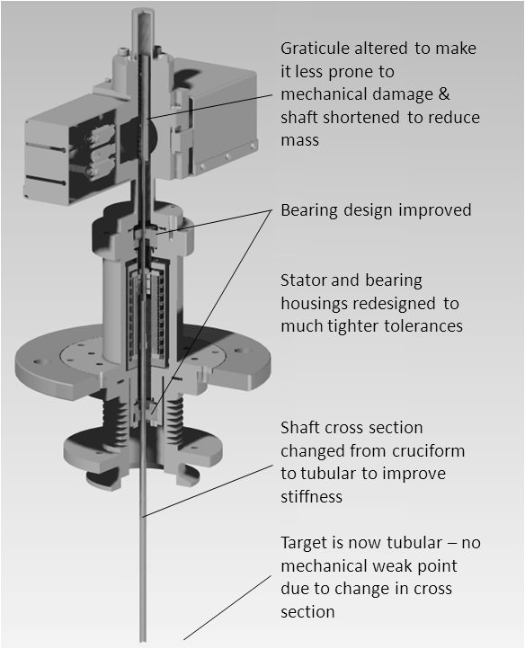

Figure 2: Cross section through the current stator design.

Target insertion is synchronised to the ISIS machine start signal. After a programmed delay, the current through the coils is increased to 60 amps to drive the shuttle through its trajectory at high acceleration. Feedback from the position sensing ensures that the correct coils are powered in sequence maintaining the maximum force on the shuttle magnets. When the target is halfway through its descent, the controller reverses the currents so that the shuttle experiences a decelerating (upward) force. This decelerates the shuttle until the target reaches its maximum insertion depth and then reaccelerates the shuttle and target back up the actuator. At a second preset point the currents are reversed again, decelerating the shuttle so that it comes to a halt at its intended holding position. At this point the microprocessor changes the mode to keep the shuttle levitated at its hold point until another actuation signal is received from ISIS.

MONITORING
The target drive is monitored continually during operation. The target positional information, total beam-loss signal produced by ISIS, beam intensity and the beam-loss produced in the vicinity of the target mechanism are currently recorded by a local PC.
The DAQ system therefore provides a record of the trajectory of the target and also allows the calculation of its velocity and acceleration. The record of ISIS beam-loss allows correlation of target behaviour with the rate of particles being lost from the ISIS beam. Measurements of the number of useful muons down the MICE beam-line by other MICE instrumentation will also be used to optimise the target insertion parameters. A second paper presented at the IPAC10 conference discusses the stability of the target motion and the correlation of beam loss and particle production with the timing and depth of the target’s intersection with the ISIS beam [3].

Upgrades
The target system has operated for over two years within ISIS. However there are some known issues with the longevity of the DLC coated bearings and further analysis of the target shaft indicated that its design could be improved. As a consequence the target design has undergone some significant modifications including a switch in its geometry from cruciform to tubular, stiffening the shaft and permitting higher tolerances. The method of assembly of the shaft has been changed to allow improvement of the alignment between the shaft and the bearings. The bearings have been redesigned so that there is no possibility of discontinuities on the bearing surface (the previous bearings were of a split design). Also the redesigned bearings can take inserts of various types of polyimide high density plastics such as VESPEL®. The redesigned target was operational within ISIS during the summer of 2009 and a program is underway to evaluate the performance of various bearing surface materials. It is intended that these improvements to the target’s mechanical design will enhance its long term reliability. This will be necessary as MICE progresses to the point where the target will be required to operate for many millions of actuations per year.
Similarly, experience gained from using the target over the previous years has shown that the control electronics requires upgrading to provide a more user friendly interface and better integration into the MICE data acquisition system. An FPGA based system with a USB interface has been chosen to provide this functionality; this redesign is currently progressing and will be implemented in three stages over the forthcoming year.

References
[1] MICE, an international Muon Ionisation Cooling Experiment: proposal to the Rutherford Appleton Laboratory, submitted to CCLRC and PPARC on the 10th January 2003, http://mice.iit.edu/micenotes/
public/pdf/MICE0021/MICE0021.pdf

[2] A. Matthews and S. S. Eskildsen. Engineering application for Diamond-like carbon. Diamond and Related Materials, April 1994, Pages 902-911
Proceedings of the 4th European Conference on Diamond, Diamond-like and Related Materials.

[3] C. Booth, P. Hodgson, R. Nicholson and P. J. Smith. MICE Target Operation and Monitoring. May 2010. To be published at IPAC10, Kyoto, Japan.

