MICE Target OPERATION & MONITORING*
C. Booth, P. Hodgson, P. J. Smith, Dept. of Physics & Astronomy, University of Sheffield, England.
Abstract
The MICE experiment requires a beam of low energy muons to demonstrate muon cooling. A target mechanism has been developed that inserts a small titanium target into the circulating ISIS beam during the last 2ms before extraction.
The target mechanism has been in operation in the ISIS beam during 2009 and a large set of useful data has been obtained describing the target’s operational parameters. This has allowed the commissioning of the initial section of the MICE beam line and instrumentation, and the close monitoring of target performance. This work describes these target parameters and presents some of the results from operational shifts.

The MICE Experiment
The Muon Ionisation Cooling Experiment (MICE) [1] has been designed to practically demonstrate the principle of ‘Ionisation Cooling’ a theoretically sound but technologically unproven method of reducing the emittance of a muon beam. Ionisation Cooling is one of many new technologies that will be required to build a next generation high intensity neutrino source such as the Neutrino Factory. Muon cooling is achieved by passing the muons through a set of absorbers within the MICE cooling channel. Axial momentum lost by the muons within the absorbers is then replaced through the use of RF cavities. MICE should demonstrate a transverse emittance reduction in the muon beam by order of 10% and will be able to measure the absolute value of the emittance of the muons to within 0.1%.

Muon Source
The source of these muons for the MICE experiment will come from the MICE ‘target mechanism’ an electro-mechanical device that operates parasitically on the ISIS accelerator. ISIS is an 800 MeV proton accelerator that forms part of a neutron spallation source, situated at the Rutherford Appleton Laboratory in the UK, also home of the MICE experiment. This target mechanism, operating at a maximum frequency of 1 Hz, inserts a small titanium target into the ISIS proton beam on demand. The target remains outside the beam envelope during acceleration and then overtakes the shrinking beam envelope to enter the proton beam during the last 2 ms before beam extraction. The target interacts with the ISIS beam halo during these 2 ms to produce pions. Their subsequent capture and decay provides the muons for the MICE experiment.

the target drive
The target drive is a brushless DC permanent magnet linear motor. This motor consists of a moving magnetic assembly that operates inside a set of 24 flat coils that are contained within the stator body. The magnetic assembly is attached to a long cylindrical titanium shaft. This shaft is magnetically propelled by the interaction of the magnets with the stator coils. This is a demanding application; the target must accelerate at ~90 g and the components of the target system must remain compatible with the ultra high vacuum of the ISIS system. A second paper presented at the PAC10 conference discusses the target hardware in more detail and so this will not be repeated here [2].

Online Monitoring
Key parameters from the target system that are recorded by the target DAQ are; the target position, the ISIS beam intensity together with several ISIS beam-loss signals. This data can be selectively displayed on a pulse by pulse basis using the EPICS based target DAQ. The ISIS beam-loss signals are derived from a series of gas ionisation chambers situated around ISIS. These signals represent the rate of proton loss from the synchrotron and are usually expressed in mV.

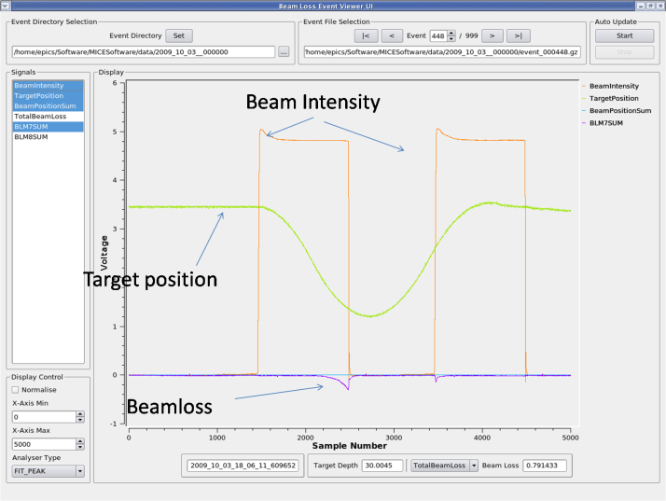
Figure 1: A screen capture of the target DAQ showing several useful operational parameters simultaneously displayed.
Figure 1 shows a screen-shot from the target DAQ during target operation. It can be seen that as the target approaches its minimum position during the latter part of an ISIS spill, a significant amount of beam-loss is recorded in sector 7, immediately downstream from the target. This beam-loss is directly attributable to the target and can be tuned to some desired value by varying the target dip depth and to some extent the insertion time. Note also that the target is moving sufficiently rapidly so as to be out of the beam by the time the next acceleration period arrives 10 milliseconds after extraction.

Offline monitoring
The data for each pulse is collected and reduced to a parameterised form during each MICE run where several key variables are derived from the individual pulse data. Using parameterised target data allows detailed examination of interesting target properties and can enable changes in the physical state of the mechanism to be monitored without direct inspection. The target maximum depth is converted into a Beam Centre Distance (BCD) measured with respect to the nominal centre line of the ISIS beam pipe.
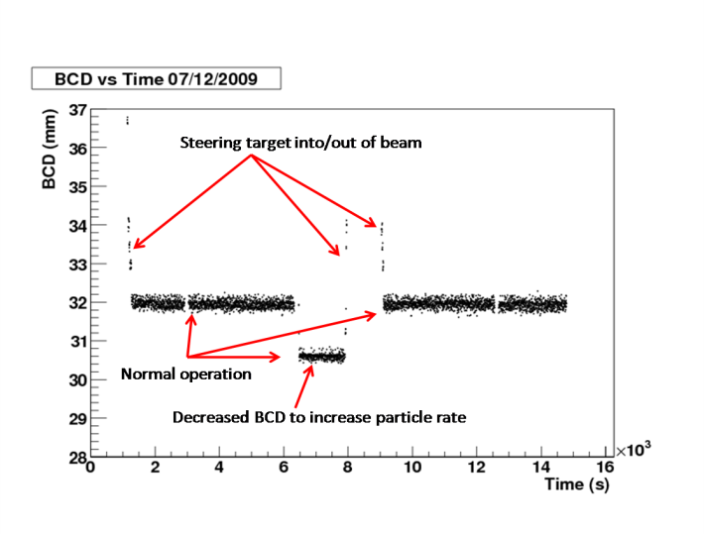
Figure 2: BCD as a function of time for a typical MICE shift in 2009. Periods where the target BCD was adjusted can clearly be seen. Also visible is the small (~0.6mm) variability in the target BCD from pulse to pulse.
Figure 2 shows a plot of the target minimum BCD over a typical MICE shift. Analysis of these plots after a run gives useful information about the performance and stability of the target. Specifically it can be seen that there is a spread in the measured values of ~0.6mm for the minimum BCD, an observation that is useful in monitoring the stability of the target.

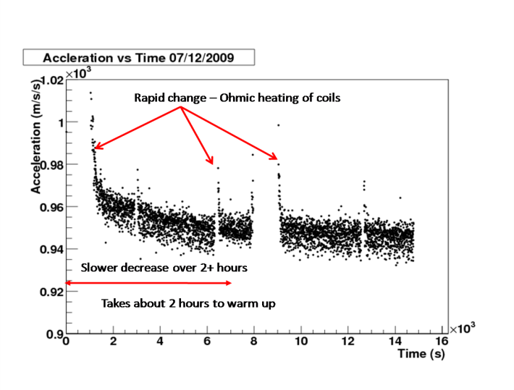
Figure 3: The maximum acceleration of the target over a typical MICE shift showing rapid decreases superimposed on a longer trend.
Figure 3 shows a plot of target acceleration against time where the acceleration is measured over the initial part of the actuation and represents the maximum acceleration of the target. The rapid decreases in acceleration over timescales of 20-30s after an initial start up are due to Ohmic heating of the coils increasing resistance and thus reducing maximum current. The longer time scale reduction is due to overall heating of the target assembly and ceases when the stator and supporting elements reach thermal equilibrium with the surroundings.

Target Stability
If the minimum BCD for a set of target pulses is examined where the target is pulsed at a fixed depth a clear pattern is visible. For targets where little wear is observed on the bearings the BCD distribution is quite narrow with a characteristic double peak structure, see figure 4 below. For a target that showed high wear a much broader distribution is observed, see figure 5 below. Obviously this can be used as key diagnostic for spotting potential problems with a target.

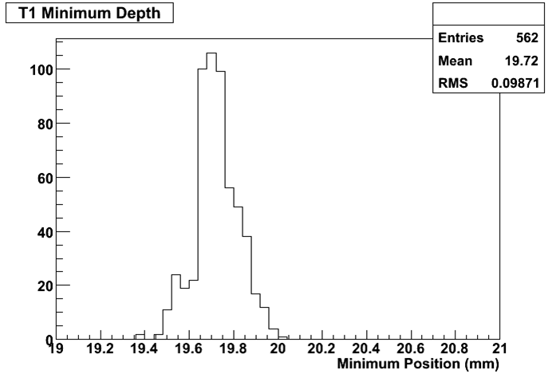
Figure 4: A BCD histogram for a target that was operating well and showed little evidence of wear.

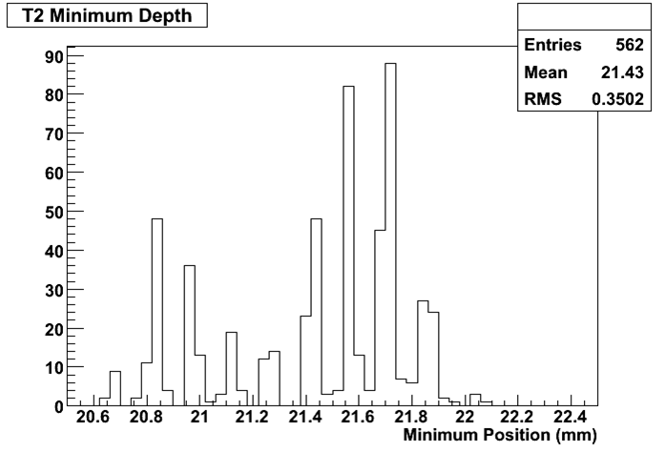
Figure 5: The BCD histogram for a failing target that was pulsing erratically and showed clear evidence of wear.

Calibration plots
In order to attempt to identify potential wear on the bearing/shaft interface, periodic calibration pulses are taken. The target is pulsed at a fixed BCD for a set period of time and the resulting data compared with that of previous runs (see figures 6, 7 and 8 below). Any substantial changes in these distributions can then be identified and appropriate action taken. 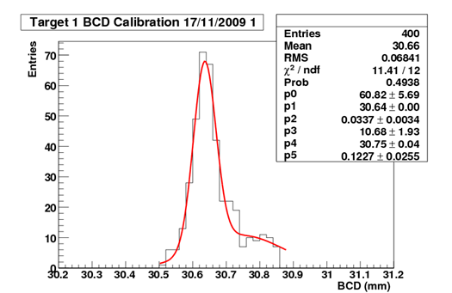
Figure 6: A BCD calibration plot fitted with a double Gaussian.
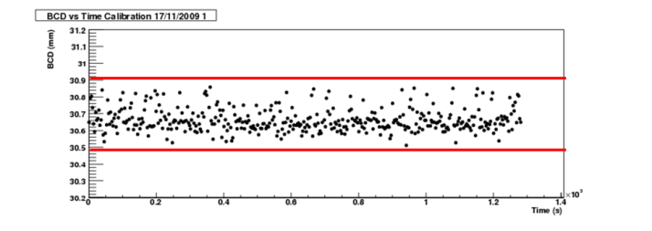
Figure 7: A BCD time series plot where all of the pulses fall within 0.6mm of the mean value.
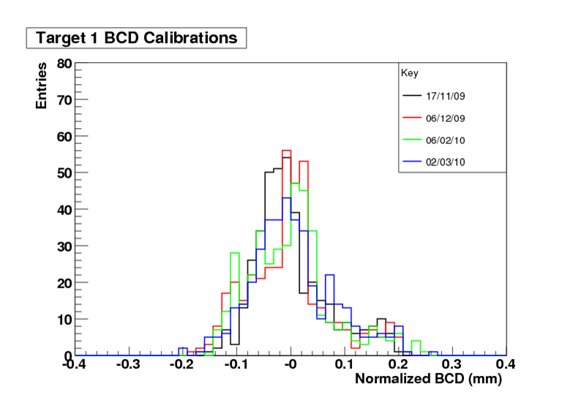
Figure 8: A set of BCD histograms from different runs taken over several months, normalised and overlaid.
The use of these calibration plots has proved to be a useful tool in identifying potential problems. Note that for the normalisation process we simply subtract the mean value of the BCD distribution from each bin entry.

PARASITIC OPERATION
During operation the target has been run at an insertion rate of ~0.5 Hz whilst ISIS has been running from this frequency up to its normal operating frequency of 50 Hz. Operation of the target with ISIS running at 50 Hz has successfully shown that the target can operate on ISIS parasitically. This was demonstrated by dipping the target at a progressively later time in the ISIS cycle until clipping of the next ISIS pulse at beam injection was observed. For an actuation depth that initially provided 50 mV of beam-loss, there was a ~3 ms window between the optimum target insertion time and where injection losses on the next ISIS pulse were observed.

correlation to the mice muon rate
Whilst most of the discussion so far has centred on the concept of beam-loss, clearly what is important to MICE is the expected muon rate in the MICE cooling channel. MICE is being installed over six stages, the ultimate aim of a full emittance reduction measurement will not be possible until after all of the components have been installed in the final stage of construction. At this point a rate of 600 muons per spill will be required to make the required emittance measurements in a reasonable time frame.
Simulations coupled with data obtained from the detectors installed in the MICE beam line indicate that the current muon rate is of the order of a few muons per spill [3]. The amount of beam-loss produced by the MICE target has been deliberately limited so far until a full understanding of the likely activation of the local environment and the disruption of the ISIS beam is understood. It is clear that the permitted beam-loss caused by the target will need to be significantly increased in the future so that it is possible to obtain the required good muon rates for MICE.

References
[1] MICE, an international Muon Ionisation Cooling Experiment: proposal to the Rutherford Appleton Laboratory, submitted to CCLRC and PPARC on the 10th January 2003, http://mice.iit.edu/micenotes/
public/pdf/MICE0021/MICE0021.pdf
[2] C. Booth, P. Hodgson and P. J. Smith. MICE Target Hardware. May 2010. To be published at IPAC10, Kyoto, Japan.
[3] A. Dobbs, D. Adams, K. Long, J. Pasternak and M. Apollonio. The MICE Muon Beam: Status and Progress. May 2010. To be published at IPAC10, Kyoto, Japan.

*We wish to thank the MICE collaboration and the ISIS Division at the STFC Rutherford Appleton Laboratory for the invaluable help and support in the performance of this work.

